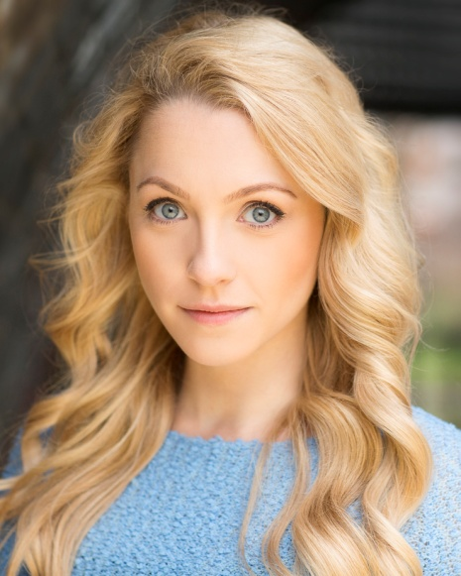Georgie Jackson

***ALCHEMY ACTIVE MANAGEMENT***

*Phone: 07827 810602 01216045770*

*E-mail: alaine@alchemyam.co.uk*

*www.georgiejackson.com*

Spotlight view pin: 9330-8972-3533

www.mandy.com/presenter/profile/georgie-jackson

Location: London, North West, West Midlands.

Height: 5'2" (157cm)

Playing Age: 16 - 25 years

Appearance: Scandinavian, White Nationality: British

Eye Colour: Blue Hair Colour: Blond(e)

Hair Length: Long Voice Quality: Bright

Voice Character: Enthusiastic

**Presenting**

2019 to Present, Radio Show Presenter and Programmer, WHAT’S HAPPENING, Redshift Radio.

2019, Presenter and Celeb Interviewer, INTERNATIONAL CHEESE SHOW AWARDS, Redshift Radio.

2019, Presenter, MMD, Chard House Media.

2019, Presenter/Host, NANTWICH FUN DOG SHOW, Richmond Village.

2019, Presenter, VERSUS, Heart Bingo.

2019, Presenter, SPIN FOR THE WIN, Heart Bingo.

2019, Presenter, VGQ, Virgin Games.

2019, Presenter, VERSUS, Heart Bingo.

2019, Presenter, VGQ, Virgin Games.

2018-2019, Presenter, LIVE SIGNATURE ROULETTE, Virgin Games.

**Theatre**

2018-2019, Pantomime, Cinderella, CINDERELLA, Anton Benson Productions LTD.

2017-2018, Pantomime, Princess Jasmine, ALADDIN, Anton Benson Productions LTD.

2016, Pantomime, Tinkerbell, PETER PAN, Shone Productions.

2015-16, Pantomime, Princess Jasmine, ALADDIN, London Contemporary Theatre.

2014, Musical, Featured Ensemble, OH WHAT A LOVELY WAR, Marc Urquhart.

2014, Musical, Madeline Forester, BEL AMI, Charing Cross Theatre, Chris Loveless.

2013, Musical, Jane, SALAD DAYS, Watermans Theatre, Stewart Nicholls.

**Televison and Film**

2016, Television, Chloe Gazzard, BRITAIN'S DEADLIEST LOVERS - THE INVESTIGATION DISCOVERY CHANNEL, Crackit Productions.

2016, Film school, Daisy (Lead), UNTITLED, The Met Film School, Tim Kodermac.

2015, Television, Misstasia, BRITAIN'S GOT TALENT LIVE SEMI FINALS, Britain's Got Talent, SYCO.

2015, Television, Georgie, Misstasia, ITV BROADER NEWS, ITV.

2015, Television, Misstasia, THIS MORNING, ITV.

2013, Music Video, Solo dancer/ character role, 'FEARLESS', REEformed, Robert Panner.

**Concerts (Singing) and Personal Appearances**

2017, Personal Appearance, NORTHWICH CHRISTMAS LIGHTS SWITCH ON.

2017, Concert, Misstasia, LEICESTER CHRISTMAS LIGHTS SWITCH ON.

2015, Concert, Misstasia, WARRINGTON CHRISTMAS LIGHTS SWITCH ON.

2015, Corporate, Misstasia, CHILDREN OF COURAGE AWARDS, Midlands Children Charity.

2015, Concert, Misstasia, KIDS FEST, Marsh Farm, Marsh Farm.

2015, Concert, Misstasia, MK PLAYDAY, MK Playday, MK Playday

2015, Concert, Misstasia, SUNNYHULL- SOLIHULL.

2015, Television, Georgie, Misstasia, ITV BROADER NEWS, ITV.

2015, Television, Misstasia, THIS MORNING, ITV.

2012, Concert, Top Soprano, SHOWSTOPPERS, Actors Church, Ian Macmillan.

2012, Corporate, Featured Ensemble, NESTLE TOURE D'OR, Marcia Carr.

**Modelling**

2016, Still Photography, Model, THE ROBING ROOM AW16 COLLECTION, The Robing Room.

2015, Model, ENGAGEMENT LIFESTYLE SHOOT, Yvette Craig Photography.

**Adverts,**

2019, Model/Featured Artist, LIVE SIGNATURE ROULETTE, Virgin Games,

2019, Actor, VLAD HOLIDAY GIVEAWAY, Virgin Games.

**Skills:**

Accents & Dialects: (* = native) Cumbrian*, English-Standard, Heightened RP, Liverpool, RP

Music & Dance: (* = highly skilled) Top Soprano, Vocal Range: 3 Octaves-bottom D-top Soprano D

Classical Singing*, Contemporary , Contemporary Singing

Dance. Ballet*, Cabaret Dancing, Hip Hop Dance, Lyrical Dance, Modern Dance,

Street Dance

Performance: Presenter, Actor, Singer, BASSC-Rapier,

Dagger & Unarmed (pass), Musical Comedy, Musical Theatre.

Sports: (* = highly skilled) Air Rifle Shooting, Archery, Climbing, Cycling, Field Hockey*,

Horse-riding, Running*, Stage Combat, Swimming*, Triathlon

Vehicle Licences: Car Driving Licence

Other Skills: Animal Handling, Lifeguard, Photographic Model

Training: London College of Music, Musical Theatre BA (Hons), 3 years, 2011 – 2014